5/16/2023

Final Project

Inventory Management System

* Group Members:

Name: Roll No:

Usama Akram 21F-9217

Shehryar 21F-9639

Huzaifa Arshad 21F-9323

Section: BCS-4C

* **Here are the Screenshots of our project:**

**First Loading page:**

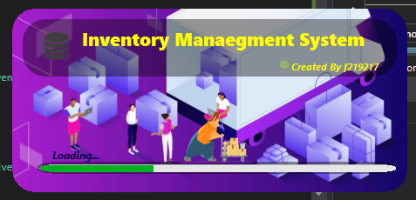

**Then Login Page:**

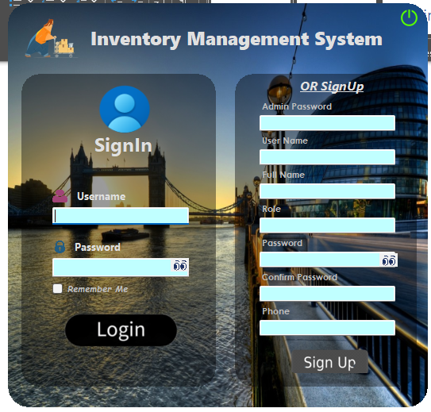

**If the user wants to sign up, he needs Admin permission, which is admin password. It is also a Novelty of our IMS.**

**Then if user has entered incorrect or incomplete details, programs throws a proper error with details, like this:**

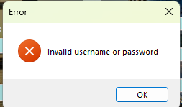

**Then comes main page:**

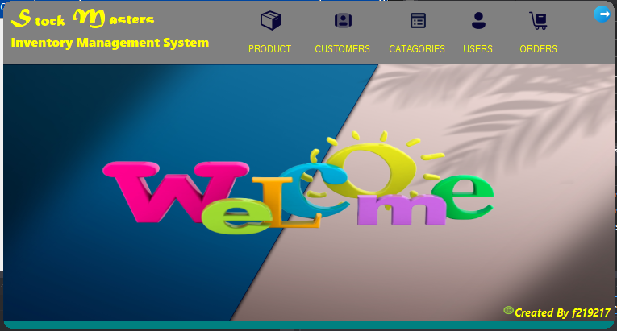

**By clicking the Tabs we can visit the target form.**

**Product Form:**

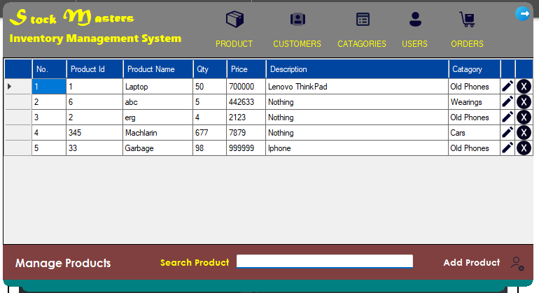

* **Product Module Form:**

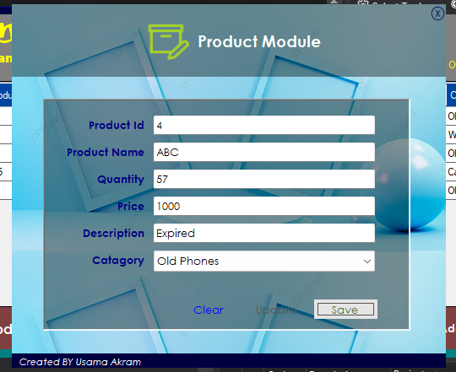

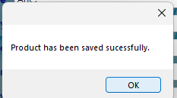

* **Searching:**

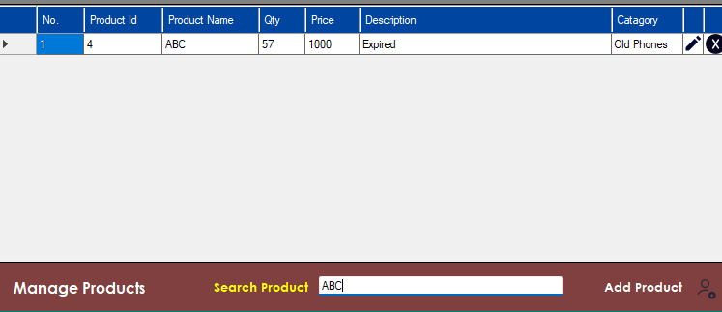

* **Customer Module:**

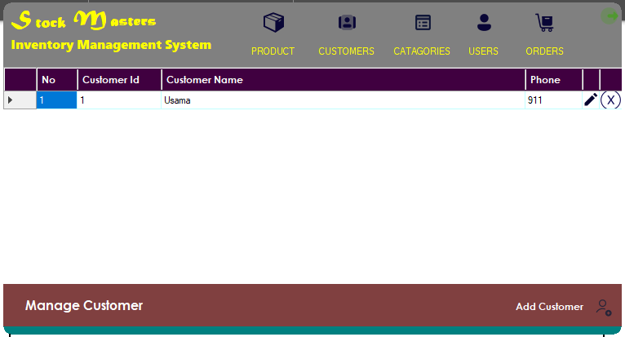

* **Customer Module:**

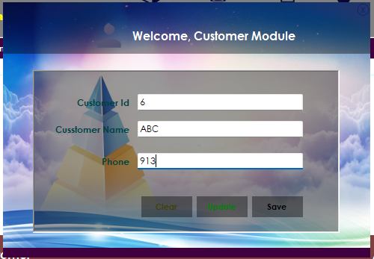

* **Manage Categories:**

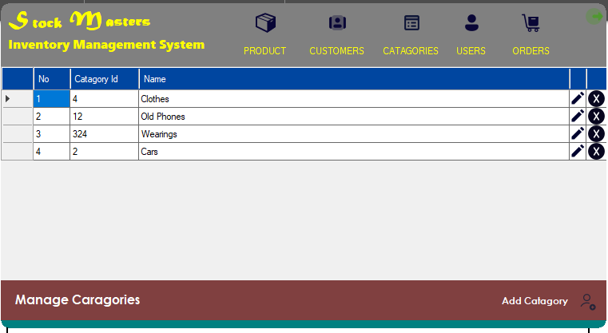

* **Category Module:**

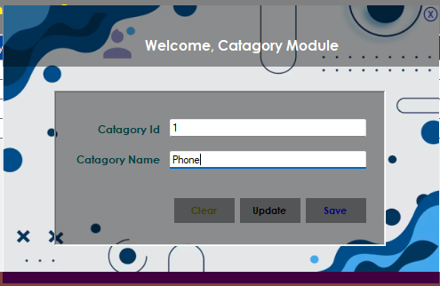

* **User Module:**

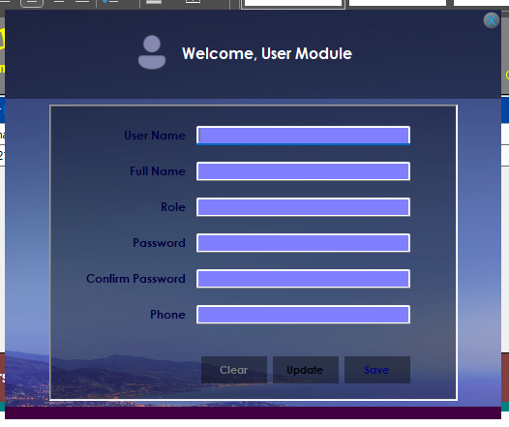

* **Manage Orders:**

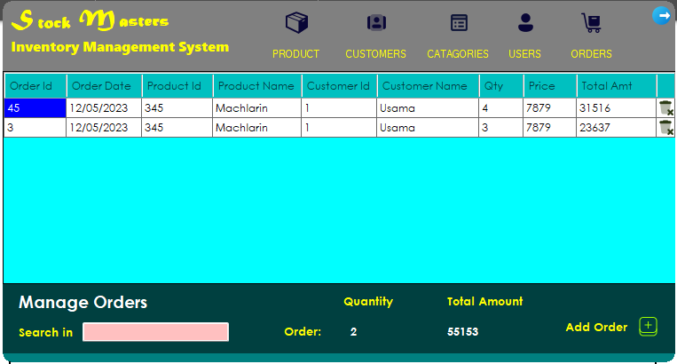

* **Order Module:**

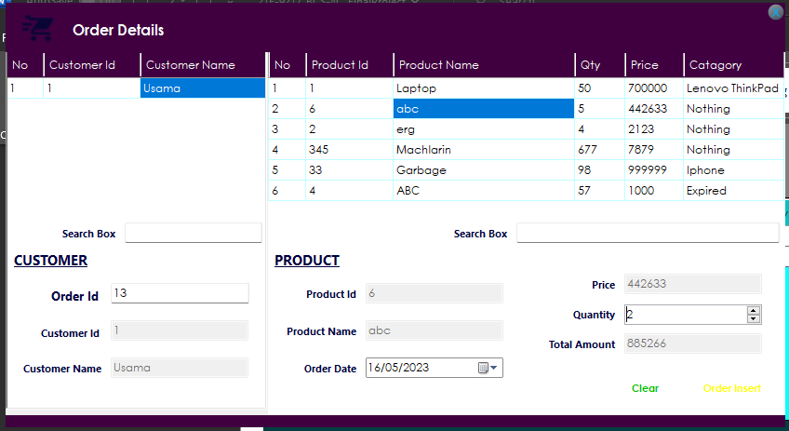

* **Inserting Order:**

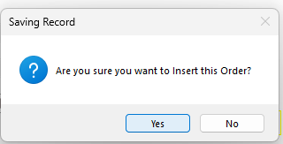

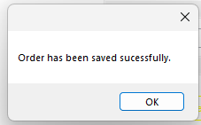

**Quantity of Product Named as ABC has been decreased from 5 to 3, since I have ordered that with quantity 2.**



* **Order added to the list is:**

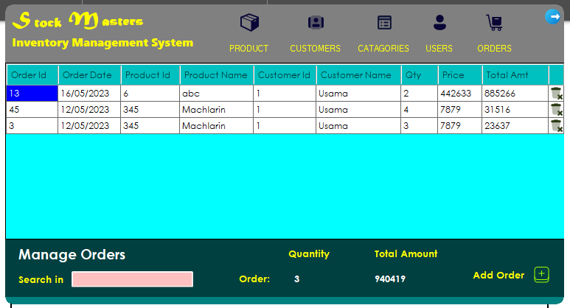

* **Searching Order:**

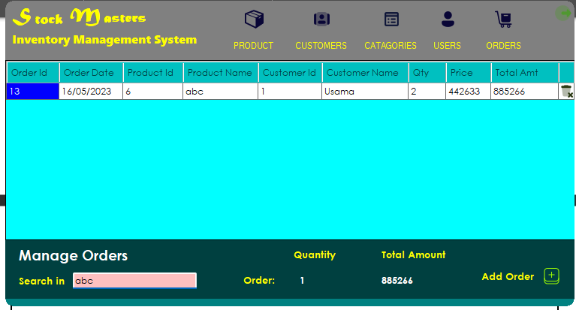

* **Closing application:**

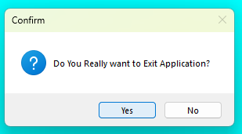



* **Novelty Features of our project are:**
* **We have added unique design interface.**
* **At login page user can also signup if he now has admin permission as his password.**
* **An Eye looking around when user shows password:**

**Before:**



**After:**

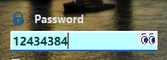

* **Customized Dashboards:**

One of the features of our project is that if admin gets logged in to the IMS, he has access to all the features and when Employees gets logged in, he has access to all the features except User Module Feature and when Customer gets logged in, he has access to all features except Managing users and Categories.

* **We have use buniful elipse to round up corners, so that they look cool/Better.**
* **Loading Page is unique.**
* **Tried to add Transparency to make our IMS look more good and better.**
* **One more Unique feature is:**

**When a person, who is not assigned with role of Admin, Employee or Customer, He is not allowed to enter into the system**

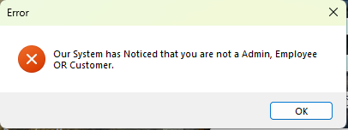

**Until He contacts DBA and gets assigned with a role:**

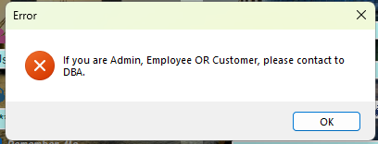



**END**